“Київський фаховий коледж зв’язку”

Циклова комісія Комп’ютерної інженерії

**ЗВІТ ПО ВИКОНАННЮ**

**ЛАБОРАТОРНОЇ РОБОТИ №9**

з дисципліни: «Операційні системи»

**Тема: «Захист системи та користувачів у Linux. Створення користувачів та груп»**

Виконавли студенти

групи РПЗ-03

Команда: Губенко Є.О.,

Заїка С.В. та Кресан Р.А.

Перевірив викладач

Сушанова В.С.

Київ 2022

**Мета роботи:**

1. Отримання практичних навиків роботи з командною оболонкою Bash.

2. Знайомство з базовими діями при створенні нових користувачів та нових груп користувачів.

**Матеріальне забезпечення занять**

1. ЕОМ типу IBM PC.

2. ОС сімейства Windows (Windows 7).

3. Віртуальна машина – Virtual Box (Oracle).

4. Операційна система GNU/Linux – CentOS.

5. Сайт мережевої академії Cisco netacad.com та його онлайн курси по Linux

**Завдання для попередньої підготовки**

***Готував матеріал студент Губенко Є.О***

1. На базі розглянутого матеріалу дайте відповіді на наступні питання:
   1. Розкрийте поняття UPG, коли їх доцільно використовувати?

*UPG is an acronym for Unified Process for Geospatial Information Management. It is a geospatial data management methodology that includes a set of processes that can be used to develop, implement and manage geospatial information systems.*

*UPG can be used in any project related to geospatial information, including geodesy, cartography, telecommunications, real estate, environment, urban planning, transportation, etc. UPG can develop and implement geospatial information systems that help organizations better manage land, surveying, mapping, transport routing and much more.*

*UPG provides a systematic approach to geospatial data management that enables organizations to make better use of their geospatial resources. UPG helps to ensure data standardization and consistency, and improves the quality and accuracy of geospatial information systems, enabling them to be used more effectively.*

* 1. Якими командами можна створити групи користувачів? Наведіть приклади.

*You can create user groups using a variety of commands in different operating systems and programs.*

*Examples of commands for creating user groups:*

* *On Windows, you can create a user group using the "net localgroup" command. For example, to create a group named "admins", open a command prompt and enter the following command: net localgroup admins /add.*
* *On Linux, you can create a user group using the "groupadd" command. For example, to create a group called "developers", open a terminal and enter the following command: groupadd developers.*
* *On MacOS, you can create a user group using the System Preferences app. Click on the System Tray icon in the Dock, open the Groups tab, and click the "+" sign to add a new group.*
* *In Microsoft Active Directory, you can create a user group using the Active Directory Users and Computers console. Right-click on the container to which you want to add a new group, select "New" and click "Group". Enter a name for the group and click OK.*
  1. Якими командами можна змінити налаштування груп користувачів? Наведіть приклади.

*Example commands for changing user group settings:*

* *On Windows, you can change the user group settings using the "net localgroup" command. For example, to add a user to the "admins" group, open a command prompt and enter the following command: net localgroup admins /add username.*
* *On Linux, you can change the user group settings using the "usermod" command. For example, to add a user named "username" to the "developers" group, open a terminal and enter the following command: usermod -a -G developers username.*
* *On MacOS, you can change the user group settings in the System Administrator app. Select the desired group and click the Options button. You can change group membership and access rights in this program.*
* *In Microsoft Active Directory, you can change the settings of a user group using the Active Directory Users and Computers console. Select the desired group and right-click on it, select "Properties" and change the settings you need.*

**Хід роботи**

***Готував матеріал студент Заїка С. В.***

1. Опрацюйте всі приклади команд, що представлені у лабораторних роботах курсу NDG Linux Essentials - Lab 15: System and User Security та Lab 16: Creating Users and Groups. Створіть таблицю для опису цих команд***.

|  |  |
| --- | --- |
| Назва команди | Її призначення та функціональність |
| su - | It is used in Unix-based operating systems such as Linux to change the user to another and start a new shell with the exported environment variables of the new user. |
| id | is used in Unix-based operating systems, such as Linux, to display information about user identifiers (UIDs) and group identifiers (GIDs). |
| head /etc/shadow | is used to display the first few lines from a file or standard input. |
| sudo head /etc/shadow | is used to run commands with elevated administrator (root) privileges in Unix-based operating systems such as Linux. |
| head /etc/passwd | is used to display the first few lines from a file or standard input. |
| grep | is used to search input strings or files for a given pattern or regular expression. It allows you to quickly find matching strings in text files or a standard input stream and display them on the screen or write them to an output file. |
| getent passwd sysadmin | allows you to get information about users, groups, host machines, and other resources stored in system databases, including /etc/passwd, /etc/group, /etc/hosts, and others. |
| w | is used to display information about users who are currently logged in to the system. This command displays information about the user's name, the terminal on which they are logged in, the time they are logged in, their status, and the command they are executing. |
| groupadd -r research | creates a new system group named research. The group will be added to the /etc/group file and will contain the group name and group ID. |
| getent group research | returns information about the group named research, which is located in the /etc/group file. This command displays a line of text containing information about the group, such as the group name, group ID, and a list of users who belong to the group. |
| useradd -D | The useradd command is used to create a new user in the system. Using the -D option, you can get the current settings that will be used when creating a new user by default. |
| nano /etc/default/useradd | opens the /etc/default/useradd configuration file for editing in a nano text editor |
| userdel -r student | is used to delete the student user from the system, along with its home directory and all files and subdirectories belonging to this user. |

***Скріншоти виконання команд в терміналі можна не представляти, достатньо коротко описати команди в таблиці.

***Готував матеріал студент Кресан Р.А.***

1. Виконайте наступні практичні завдання у терміналі наступні дії (продемонструвати скріншоти):
   * **виведіть інформацію про поточного користувача різними способами (підказка використовуйте команди id та grep);**

*The displayed information includes the user identifier (UID), the user group identifier (GID), and a list of additional user groups.*

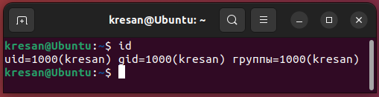

*The displayed information contains information about the user in the /etc/passwd file, including the user and group ID.*

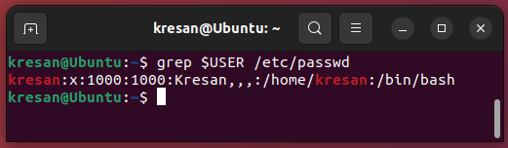

* + **попрактикуйте в терміналі команди last, w та who. Порівняйте результати виводу кожної команди, які деталі відсутні в кожній із команд порівняно з іншими?**

*The last command displays information about previous user logins. It displays a list of users who have successfully logged in, as well as the time they logged in and out. It also displays the terminal from which they were logged in.*

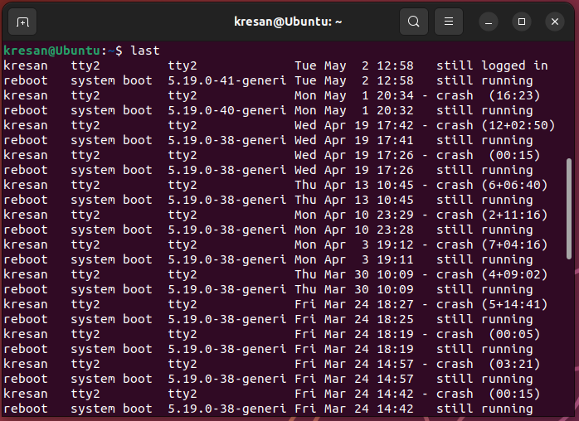

*The w command shows who is currently logged in and what processes they are performing. It also shows information about the time users are working and which terminal they are working from.*

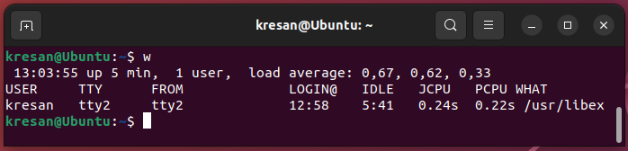

*The who command displays only a list of users who are currently logged in to the system, as well as information about the terminal from which they logged in.*

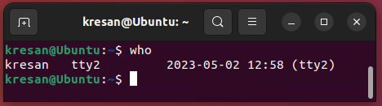

* + **створіть дві нові групи користувачів - super_admins, noob_users та good_students, визначте їх ідентифікатори;**

*To create new user groups, you can use the groupadd command. The IDs of the newly created groups can be checked using the grep command and the /etc/group file, where the user group data is stored.*

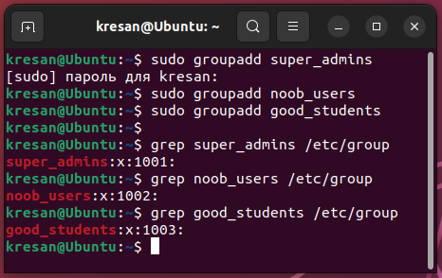

* + **для кожного члену Вашої команди за допомогою терміналу створіть нового користувача (якщо працюєте самі, то просто трьох довільних користувачів), не забудьте після створення нового користувача одразу задати йому пароль;**

*To create a new user in Linux, you can use the adduser command. When you run the command, the system will ask you to enter a password for the new user and will also ask for additional information about the user, such as name and phone number. This information is optional and can be skipped by pressing Enter..*

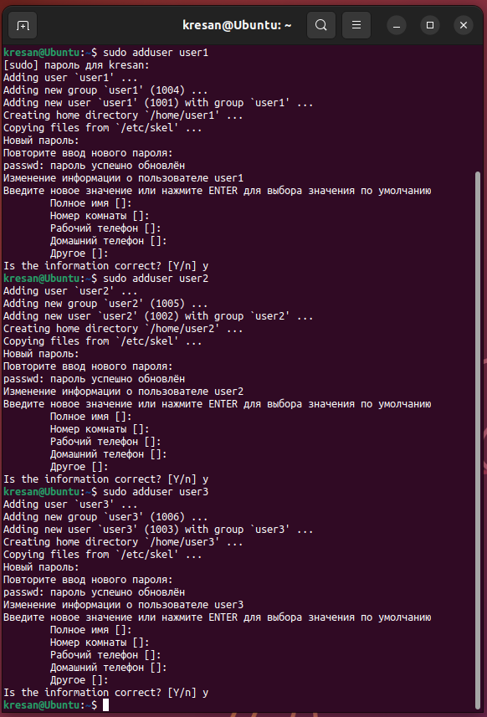

* + **додайте нових користувачів у створені Вами нові групи таким чином, щоб у групах super_admins та noob_users було по 2 користувачі, один з яких є в обох групах, у групу good_students додайте всіх трьох користувачів;**

*To add a user to a group, you can use the usermod command.*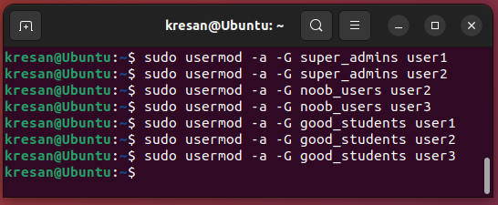

* + **перегляньте інформацію про групи, та які користувачі до них входять, поясніть що ви бачите;**

*You can view information about groups and their members using the getent command.*

*Let's view the information on the super_admins group. Here 1001 is the group ID, and user1, user2 are users who belong to this group.*

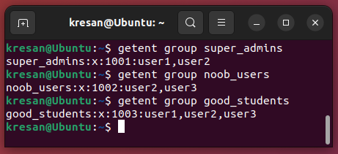

* + **видаліть першого створеного вами користувача, перегляньте чи залишиться інформація про нього в групах, де він перебував;**

*To delete a user, you can use the userdel command, passing it the name of the user you want to delete. After executing this command, the information about user1 will be deleted from the system. To check if the user's information is still in the groups, you can use the getent command again. If the output of this command contains a mention of the user user1, it means that information about him is still in the group. Otherwise, the information about the user is not in the group. In my case, the information about the user in the group was deleted.*

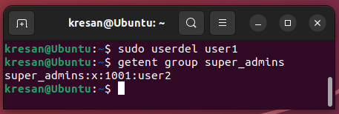

* + **видаліть другого користувача, перегляньте чи залишиться інформація про нього в групах, де він перебував;**

*When user user2 was deleted, information about him in groups disappeared.*

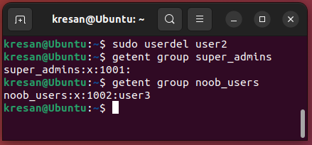

* + **видаліть третього користувача, перегляньте чи залишиться інформація про нього в групах, де він перебував;**

*When user user3 was deleted, the information about him in the groups in which he was a member disappeared.*

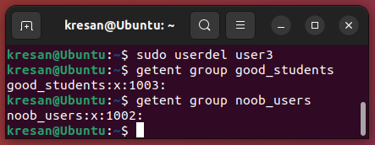

* + **перегляньте інформацію про існуючі групи користувачів;**

*To view a list of all groups, you can run the getent group command. This command displays a list of all groups on the system, along with information about their IDs and members.*

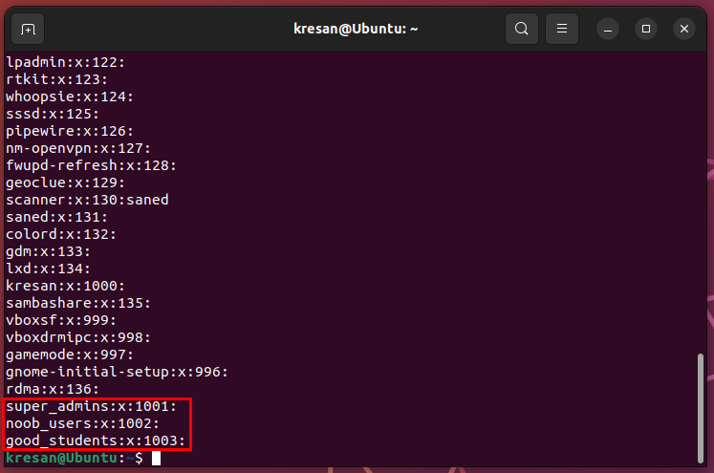

*Since we deleted the users we created, the information about them in the group disappeared, so the groups are empty.*

* + **видаліть створені Вами групи користувачів;**

*To delete a user group on Linux, you can use the groupdel command followed by the name of the group you want to delete. After executing this command, information about the deleted group will be deleted from the /etc/group file. At the same time, users who were in this group will be left without a group, and their group will be changed to users.*

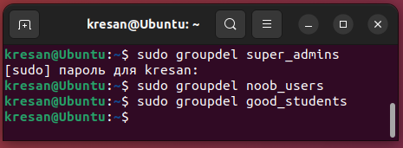

* + **перегляньте інформацію про існуючі групи користувачів.**

*After running the getent group command, we notice that the groups we created have disappeared.*

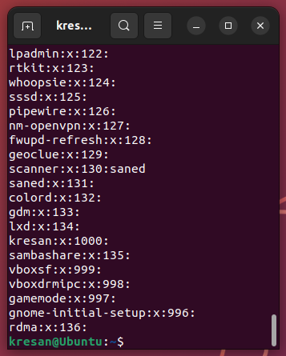

***Готував матеріал студент Губенко Є.О***

**Відповіді на контрольні запитання**

1. Чому в конфігураційних файлах паролі не зберігається в явному вигляді?

*In configuration files, passwords are usually not stored explicitly to ensure data security. If a password is stored explicitly, anyone who has access to the file can see the password and use it to gain unauthorized access to the system.*

*One method of protecting passwords in configuration files is to encrypt the password using an encryption algorithm. The encrypted password can be stored in the configuration file, and only those who know the decryption key can see the password. This allows you to keep the password in a secure form and reduce the risk of unauthorized access.*

*Another method of protection is to store a hash value of the password in the configuration file instead of the password itself. A hash value is a mathematical function that converts the input data (in this case, the password) into a fixed-length output value. When a user enters a password, the system calculates the hash value of the entered password and compares it to the stored hash value. This method protects the password in the configuration file, since even if the file falls into the hands of an attacker, he or she will not be able to see the password itself.*

1. Чому не рекомендується виконувати повсякденні операції, використовуючи обліковий запис root?

*The root account in Linux has the highest privileges, allowing the user to perform any operation on the system. Using the root account for everyday operations can lead to the risk of reduced system security, malfunctions, and even data loss.*

*Here are a few reasons why it is not recommended to perform day-to-day Linux operations from the root account:*

* *Unauthorized access: If the root account is compromised, an attacker can access all files and directories on the system and perform any operations. This can lead to the loss of confidential data and critical consequences for the system.*
* *Accidental error: Performing day-to-day operations with the root account can lead to accidental errors that can cause system crashes or data loss. For example, accidentally deleting an important file or directory.*
* *Imperfection of programs: Most programs have not been designed with security and execution as root in mind. If you run these programs from the root account, there is a risk of program malfunctions or unpredictable behavior.*
* *Unpredictable behavior: Using the root account for day-to-day operations can have unpredictable system behavior. For example, some programs may behave differently with root privileges, which can cause problems with their operation.*

1. У чому відмінність механізмів отримання особливих привілеїв su і sudo?

*The su and sudo special privilege mechanisms in Linux allow users to obtain administrator privileges to perform tasks that require elevated access rights. However, their operating principles and mechanisms differ.*

*The su command allows the user to switch to the root user account by entering the root password. Once a user has root privileges, he or she can perform any tasks with administrator rights, but has no restrictions on access to system resources.*

*In the case of sudo, the user is granted the right to execute a specific command or set of commands with elevated access rights, usually after entering their own password. The difference from su is that sudo allows you to configure access details, such as restricting access to certain commands, limiting the time of elevated rights, recording relevant actions in the log, etc. In addition, sudo allows you to execute commands with elevated privileges without having to enter the root password.*

1. Чому домашній каталог користувача root не розміщено в каталозі /home?

*The root user's home directory is not located in the /home directory for technical and security reasons.*

*One of the main principles of file system design in Unix-like systems is that each user account should have its own home directory where user information and configuration files are stored. Usually, the user's home directory is located in the /home subdirectory.*

*However, the root user account is special, and its home directory is located elsewhere on the file system. Usually, the root user's home directory is located in the /root directory. This is done for technical reasons - in many Unix-like systems, the /home user directory can be mounted from another file system, and it may not be accessible if the file system fails to mount. In addition, the use of a separate /root directory allows for greater system security, since the root user's home directory contains confidential information that should be accessible only to the user with root privileges.*

1. Для чого використовується команда getent?

*The getent command is used to retrieve information about users, groups, network services, and other system objects from sources defined in the /etc/nsswitch.conf system file.*

*By default, in Unix-like systems, information about users, groups, hosts, and other system objects is stored in special file databases such as /etc/passwd, /etc/group, /etc/hosts, etc. However, other sources of information can be used, such as a centralized database, LDAP server, or NIS server.*

*The getent command allows you to get information about system objects from any of these sources, depending on the settings in /etc/nsswitch.conf. For example, the getent passwd command will return a list of all users from all available sources, including /etc/passwd, a database, an LDAP server, or an NIS server.*

*In addition, the getent command can be useful for troubleshooting some user authentication or authorization issues. For example, if you are having trouble accessing files, using the getent group command can help determine if a user belongs to the appropriate group and has access to those files.*

1. Яким чином можна видалити існуючі групи користувачів? Чи залишиться інформація про них десь у системі?

*To delete a user group in Linux, you can use the groupdel command. Command syntax: sudo groupdel <group_name>.*

*For example, to delete a group named testgroup, you can run the following command: sudo groupdel testgroup*

*After running this command, the group will be removed from the system, and information about it will be deleted from the /etc/group file.*

*However, if the group had users that belonged to it, the information about these users will remain in the /etc/passwd file, but their membership in the deleted group will be removed. This can create problems with access rights to files and directories that were available only to this group. Therefore, before deleting a group, you should make sure that there are no users who belong to it or move them to other groups.*

*Some systems may have additional mechanisms for storing group information, for example, an LDAP server or NIS server may be used. In this case, information about groups can be stored on these servers, and after the group is deleted from the local system, information about it can remain on the server. Therefore, if you use these servers, you should make sure that the information about the deleted groups is also deleted on the servers.*

1. Як можна змінити пароль користувача?

*To change a user's password in Linux, you can use the passwd command. If you call the command without parameters, the password for the current user is changed. If you specify a username as a parameter, the password for the specified user will be changed.*

*Syntax of the command to change the password for the current user: passwd*

*Command syntax for changing the password of another user: sudo passwd <username>.*

*After calling the passwd command, the executor will be prompted to enter a new password. After that, you need to confirm the new password by re-entering it. If the new password meets the security requirements (sufficiently complex), the password will be changed, otherwise the executor will be prompted to enter the new password again.*

*For example, to change the password of a user named user1, you can run the following command: sudo passwd user1*

*After that, the executor will be prompted to enter a new password for user1.*

*It is also possible to change a user's password without using the command line using the graphical interface. To do this, open the system settings, find the Users section, select the user whose password you want to change, and click the Change Password button. Next, follow the instructions that appear on the screen.*

1. Яке призначення команди chage?4

*The chage command is used to change user password settings in Linux, such as password expiration date, last password change date, minimum password expiration date, etc.*

*The main purpose of the chage command is to change user password parameters, namely:*

* ***chage -d <date> <user_name>*** *- sets the date of the last password change.*
* ***chage -E date> <user_name>*** *- sets the date when the user's password will become invalid.*
* ***chage -m <min_expiration_date> <user_name>*** *- sets the minimum password validity period.*
* ***chage -M <max_expiration_date> <user_name>*** *- sets the maximum password validity period.*
* ***chage -W <warning_term> <user_name>*** *- sets the period for which a notification of the need to change the password will be sent before the password expires.*

*For example, to set the maximum password validity of user1 to 90 days, you can run the following command: sudo chage -M 90 user1*

*To view the current user password settings, you can use the chage command without parameters: sudo chage <username>.*

*This command will show the current password settings of the user, such as the date of the last password change, minimum password expiration, maximum password expiration, etc..*

1. Які параметри команди usermod ви вважаєте найбільш використовуваними?

*The usermod command is used to change user settings in a Linux system. The most commonly used command parameters are as follows:*

* ***-a або --append****: This option allows you to add a user to additional groups without replacing their current groups. For example, usermod -a -G groupname username will add a user to the groupname group without changing their current groups.*
* ***-d або --home****: This option allows you to change the user's home directory. For example, usermod -d /new/home/directory username will change the user's home directory from the default /home/username to /new/home/directory.*
* ***-l або --login****: This option allows you to change the user's login. For example, usermod -l newusername username will change the user's login from username to newusername.*
* ***-g або --gid****: This option allows you to change the primary user group. For example, usermod -g groupname username will change the primary user group to groupname.*

*These are the most commonly used options, but the usermod command has other options that can also be useful in different situations. For more information about the usermod command, use the man usermod command.*

***Готував матеріал студент Заїка С. В.***

**Висновки**

In the course of the laboratory work, we gained practical skills in working with the Bash shell. We got acquainted with the basic steps for creating new users and new user groups.